PRACTICUM NARRATIVE REPORT

Presented to the
Faculty of College of Computing Studies
JOSE RIZAL MEMORIAL STATE UNIVERSITY
The Premier University in Zamboanga del Norte
Main Campus, Dapitan City

In Partial Fulfillment
of the Requirements for the Course
CS PRC 1 – PRACTICUM FOR COMPUTER SCIENCE

CHRISTIAN S. SALAZAR
August 2026
TABLE OF CONTENTS
Chapter Page
1 HOST TRAINING ESTABLISHMENT PROFILE
Overview of the Host Training Establishment 3
Brief History 3
Logo and Its Meaning 4
Core Values 4
Philosophy 4
Vision 4
Mission 4
Goal 5 Organizational Chart 5
2 TRAINING ACTIVITIES
Narrative Experience 6
Daily Time Record . 30
Documentation 32
Evaluation Sheet 43
Certificate of Completion 48
3 RESULTS AND FINDINGS
Accomplishment/Contribution 48
Competencies Gained 49
Project/Output 50
Impact to Chosen Career 53
APPENDICES
A Students Copy from the Registrar 73
B Certificate of Attendance / Seminar 73
C Medical Certificate and Laboratory Results 75
D Notarized Parent’s Consent and Waiver 76
E Letter of Acceptance from the Host Training Establishment 79
F Application Letter
G Resume
H Memorandum of Agreement 79

Chapter 1
HOST TRAINING ESTABLISHMENT PROFILE
Overview of the Host Training Establishment
Describe the host training establishment...
Brief History
The Schools Division Office of Dapitan City is a local office of the Department of Education (DepEd) responsible for managing and supervising the delivery of quality basic education in Dapitan City. It oversees public elementary and secondary schools, implements DepEd programs and policies, and ensures that learners receive accessible and quality education. The division continuously works to improve educational services through effective leadership, collaboration, and innovation.
Logo and Its Meaning

Core Values
The Schools Division Office of Dapitan City upholds the core values of the Department of Education:
- Maka-Diyos – God-centered and morally upright.
- Makatao – Respectful, compassionate, and humane.
- Makakalikasan – Environmentally responsible.
- Makabansa – Patriotic and committed to nation-building.

Philosophy
The Schools Division Office of Dapitan City believes that every learner has the right to quality, equitable, culture-based, and complete basic education. Education serves as a powerful tool for personal growth, community development, and national progress. The division promotes learner-centered education that develops competent, responsible, and values-oriented citizens.
Vision
We dream of Filipinos who passionately love their country and whose values and competencies enable them to realize their full potential and contribute meaningfully to building the nation. As a learner-centered public institution, the Department of Education continuously improves itself to better serve its stakeholders.
Mission
To protect and promote the right of every Filipino to quality, equitable, culture-based, and complete basic education where:
- Students learn in a child-friendly, gender-sensitive, safe, and motivating environment;
- Teachers facilitate learning and constantly nurture every learner;
- Administrators and staff ensure an enabling and supportive environment for effective learning;
- Families, communities, and stakeholders actively share responsibility in developing lifelong learners.

Goals
The Schools Division Office of Dapitan City aims to:
- Provide quality and inclusive basic education for all learners.
- Improve learners' academic performance and holistic development.
- Strengthen teacher competence and professional growth.
- Enhance school governance and accountability.
- Foster partnerships with parents, communities, and stakeholders.
- Promote innovation and continuous improvement in educational services.
- Ensure a safe, supportive, and learner-friendly educational environment.

Organizational Chart

Chapter 2
TRAINING EXPERIENCE

Narrative Experience

WEEKLY PROGRESS REPORT

DepED Division Dapitan City
Week 1

DATE | DAILY ACTIVITY | LEARNING COMPETENCIES
June 17, 2026 | Organizing hardware, books in DepED Storage Room
June 18, 2026 | Brainstorming about the systems structure

Prepared:

CHRISTIAN S. SALAZAR
Student Trainee

Noted:

LOURENCE N. REYES
Information Technology Officer - I

WEEKLY PROGRESS REPORT

DepED Division Dapitan City
Week 2

DATE | DAILY ACTIVITY | LEARNING COMPETENCIES
June 22, 2026

June 23, 2026 | Repairing of Printers (2 printer repaired)
June 24, 2026 | Sorting documents
June 25, 2026

June 26, 2026

Prepared:

CHRISTIAN S. SALAZAR
Student Trainee

Noted:

LOURENCE N. REYES
Information Technology Officer - I
WEEKLY PROGRESS REPORT

DepED Division Dapitan City
Week 3

DATE | DAILY ACTIVITY | LEARNING COMPETENCIES
June 29, 2026

June 30, 2026

July 1, 2026

July 2, 2026

July 3, 2026

Prepared:

CHRISTIAN S. SALAZAR
Student Trainee

Noted:

LOURENCE N. REYES
Information Technology Officer - I

WEEKLY PROGRESS REPORT

DepED Division Dapitan City
Week 4

DATE | DAILY ACTIVITY | LEARNING COMPETENCIES
July 6, 2026

July 7, 2026

July 8, 2026

July 9, 2026

July 10, 2026

Prepared:

CHRISTIAN S. SALAZAR
Student Trainee

Noted:

LOURENCE N. REYES
Information Technology Officer - I

WEEKLY PROGRESS REPORT

DepED Division Dapitan City
Week 5

DATE | DAILY ACTIVITY | LEARNING COMPETENCIES
July 13, 2026

July 14, 2026

July 15, 2026

July 16, 2026

July 17, 2026

Prepared:

CHRISTIAN S. SALAZAR
Student Trainee

Noted:

LOURENCE N. REYES
Information Technology Officer - I

WEEKLY PROGRESS REPORT

DepED Division Dapitan City
Week 6

DATE | DAILY ACTIVITY | LEARNING COMPETENCIES
July 20, 2026

July 21, 2026

July 22, 2026

July 23, 2026

July 24, 2026

Prepared:

CHRISTIAN S. SALAZAR
Student Trainee

Noted:

LOURENCE N. REYES
Information Technology Officer - I

WEEKLY PROGRESS REPORT

DepED Division Dapitan City
Week 7

DATE | DAILY ACTIVITY | LEARNING COMPETENCIES
July 27, 2026

July 28, 2026

July 29, 2026

July 30, 2026

July 31, 2026

Prepared:

CHRISTIAN S. SALAZAR
Student Trainee

Noted:

LOURENCE N. REYES
Information Technology Officer - I

DAY | MORNING |  | AFTERNOON |  | OVERTIME |  | TOTAL HOURS | CERTIFIED BY
 | IN | OUT | IN | OUT | IN | OUT
1
2
3
4
5
6
7
8
9
10
11
12
13
14
15
16
17
18
19
20
21
22
23
24
25
26
27
28
29
30
TOTAL HOURS

DAY | MORNING |  | AFTERNOON |  | OVERTIME |  | TOTAL HOURS | CERTIFIED BY
 | IN | OUT | IN | OUT | IN | OUT
1
2
3
4
5
6
7
8
9
10
11
12
13
14
15
16
17
18
19
20
21
22
23
24
25
26
27
28
29
30
31
TOTAL HOURS
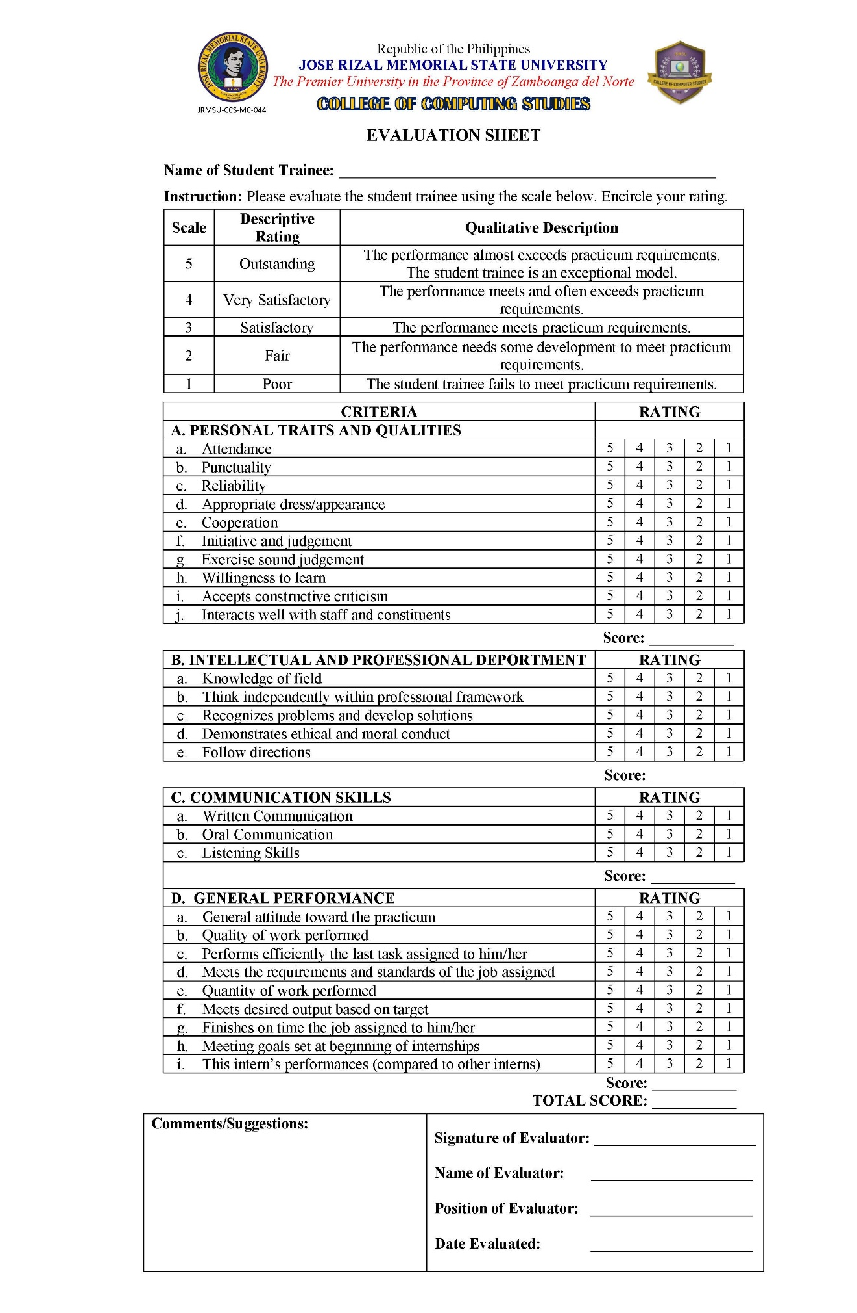

Certificate of Completion
Attached a scan copy of the certificate of completion

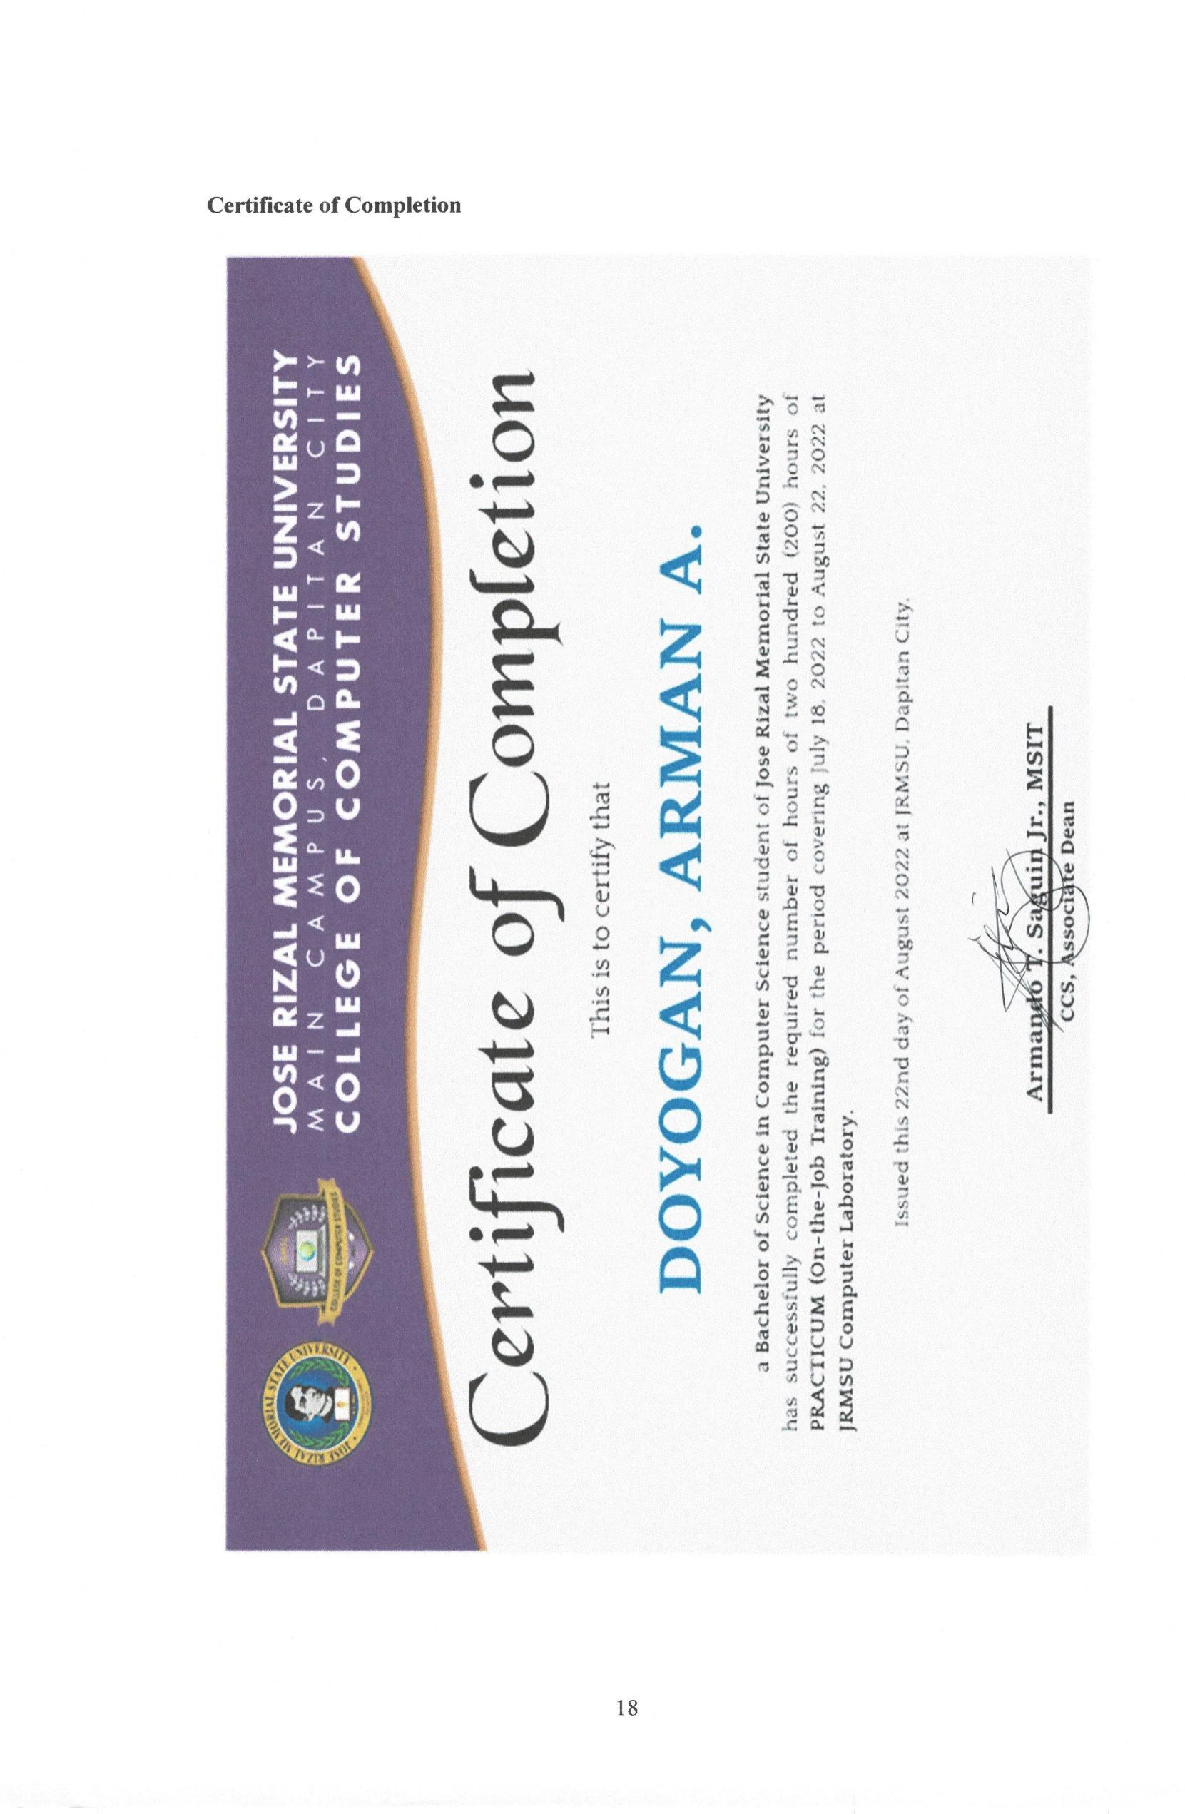
Chapter 3
RESULTS AND FINDINGS
Accomplishment/Contribution
Summarize what you have accomplished/contributed to the HTE…
Competencies Gained
Elaborate the competencies gained (based on the Possible Learning Competencies)
Project/Output
Described what legacy you have left in the HTE…
Impact to Chosen Career
Described how the OJT impact to your chosen career…

A P P E N D I C E S

- Students Copy from the Registrar

Attached a scan copy of the student copy from the Registrar

- Certificate of Attendance / Seminar

Attached a scan copy of your certificate from Guidance.

- Medical Certificate and Laboratory Results

Attached a scan copy of the medical certificate followed by laboratory results

- Notarized Parent’s Consent and Waiver

Attached the original copy of the notarized parent’s consent and waiver

- Letter of Acceptance from the Host Training Establishment

Attached a scan copy of the letter of acceptance, (ok lang ang application letter na naa signed na approved mo mag-OJT sa HTE.)

- Application Letter

- Resume

- Memorandum of Agreement
Attached a scan copy of the MOA

